Carti Hotel Management System

Use-Case-Realization Specification: View Revenue Report

Version <1.0>

Revision History

| **Date** | **Version** | **Description** | **Author** |
| --- | --- | --- | --- |
| 25/Nov/2024 | 1.0 | Final Version | Hoang Sinh Hung |
|  |  |  |  |
|  |  |  |  |
|  |  |  |  |

Table of Contents

1. Introduction 4

1.1 Purpose 4

1.2 Scope 4

1.3 Definitions, Acronyms, and Abbreviations 4

1.4 References 4

1.5 Overview 4

2. Flow of Events—Design 4

3. Derived Requirements 4

Use-Case-Realization Specification: View Revenue Report

# Introduction

## Purpose

This document describes how the Display Revenue Report use-case is realized within the design model of the Carti Hotel Management System projects.

## Scope

This document applies to the Carti Hotel Management System.

## Definitions, Acronyms, and Abbreviations

None.

## References

None.

## Overview

The subsequent sections comprehensively address the design and associated requirements of the use case. In particular, the flow of events-design part presents the class diagram and sequence diagram, accompanied by concise textual explanations to facilitate understanding.

The subsequent section outlines the derived requirements essential for the implementation of the use case. These requirements serve as crucial guidelines to ensure the successful realization and functionality of the use case.

# Flow of Events—Design

The two diagrams illustrate the essential classes and the sequence of interactions involved in the Report Revenue use case.

Upon successfully logging in as an admin, the system navigates the user to the Admin Page. Following this, the loadRoom() function is called, triggering the getRoom() method in the Room Controller. This method retrieves the required room data, including room numbers and their availability statuses. Subsequently, the showRoom() method is invoked to display the fetched data on the Admin Page.

From the Admin Page, the admin initiates the process of generating a revenue report by clicking the "Revenue Report" button. The Revenue Controller then handles the request by invoking the getRevenue() and getRevenueInfo() methods to fetch the relevant revenue data from the database.

On the Revenue Report Page, the admin is presented with four report options: daily, weekly, monthly, and yearly. The admin can select their preferred option, prompting the system to invoke the appropriate loading function: loadMonthlyRevenueReport(), loadDailyRevenueReport(), loadWeeklyRevenueReport(), or loadYearlyRevenueReport(). Each function sends a request to the Revenue Controller to process the selected report type.

The Revenue Controller then executes the respective methods: getDailyReport(), getWeeklyReport(), getMonthlyReport(), or getYearlyReport(), to fetch the necessary data. Once the data is retrieved, the system calls the corresponding display methods — showDailyReport(), showWeeklyReport(), showMonthlyReport(), or showYearlyReport() — to render the report on the Revenue Report Page, providing the admin with the requested financial insights.

## Sequence diagram

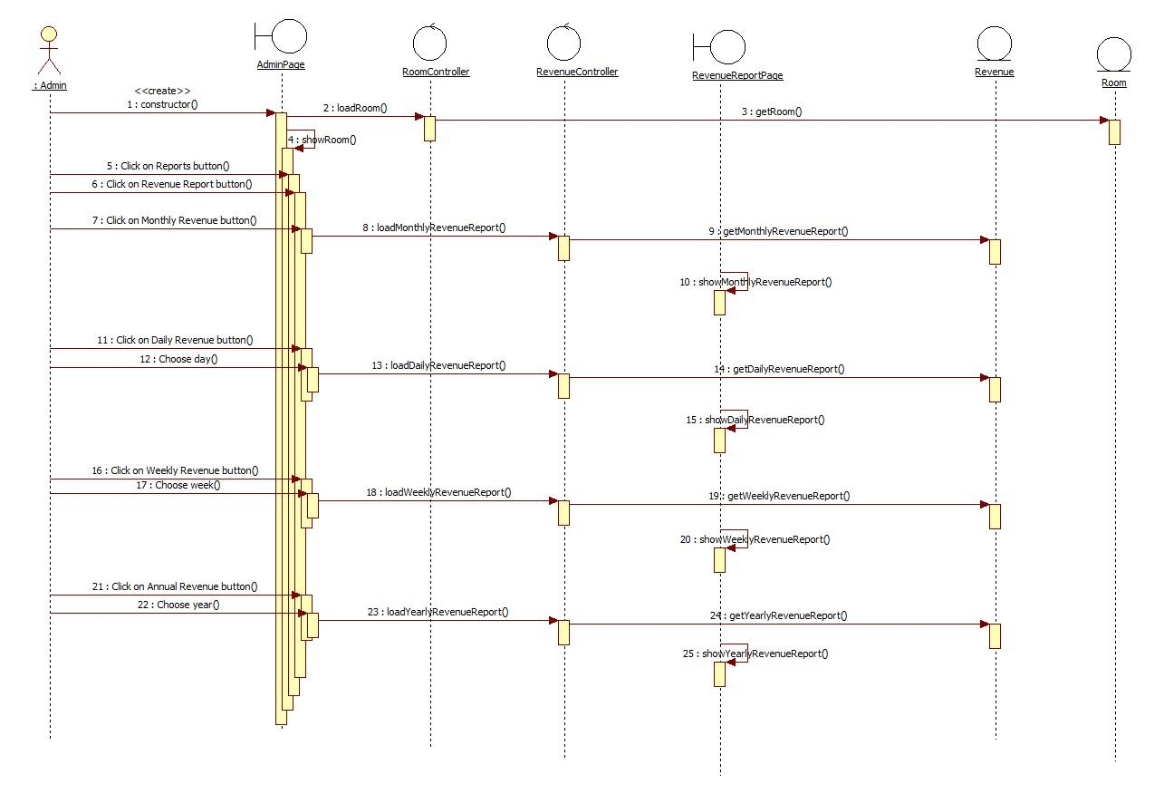

## Class diagram

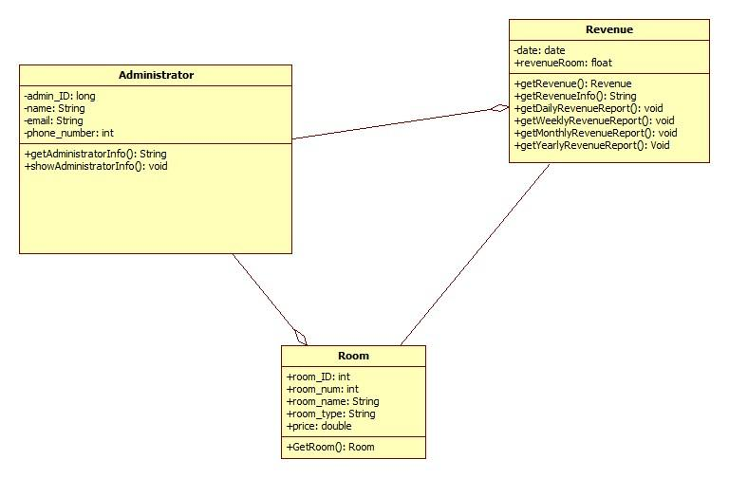

# Derived Requirements

None.